Programme | London Health Data Strategy

Document | Data at Scale Improvement Projects – Invitation to apply

Background
The London Health Data Strategy Programme is an initiative from the NHS in London supported by five London Universities, OneLondon, Health Data Research UK and NHSX.
The Mayor’s vision for London set a shared ambition to make the capital “the healthiest global city, and the best global city in which to receive health and care services’. For the 8.9 million people living in London, which is 16 per cent of England’s population, the benefits and challenges of an urban environment can interact in complex ways. Transforming the health of Londoners is complex and requires a partnership approach bringing together the 1,500 GP practices, and other community providers, that form the cornerstone of London’s health system, with the specialised providers and academic Institutions that deliver some of the best clinical outcomes and research in the world.
COVID-19 highlighted the need to integrate health and care data to provide real-time information in for service delivery, service planning and research. Despite London hosting having some of the richest datasets in the world it can be fragmented, inconsistently structured and cumbersome to access, severely limiting its potential to support improvements across the capital.
This programme aims to address this and our vision is to join up data from across the London system to create a data platform that will:
• Provide insights and intelligence on up to ten million people;
• Connect research and clinical care to create a genuinely learning health system;
• Drive collaboration between existing initiatives to make London a world-leader in the use of data to improve health outcomes.
We will achieve this through creating Findable, Accessible, Interoperable and Reusable (FAIR) rich datasets and providing the expertise to support their responsible use in research and innovation. The impact will be to position London at the forefront of data driven innovation, creating a ‘one-stop’ service for trustworthy, multi-stakeholder use of curated London data for public, private and third sector benefit.
During the first phase of this bold and ambitious programme, supported by Health Data Research UK we competitively selected and then supported a cohort of four Pathfinder Projects that looked at a range of health improvement opportunities:
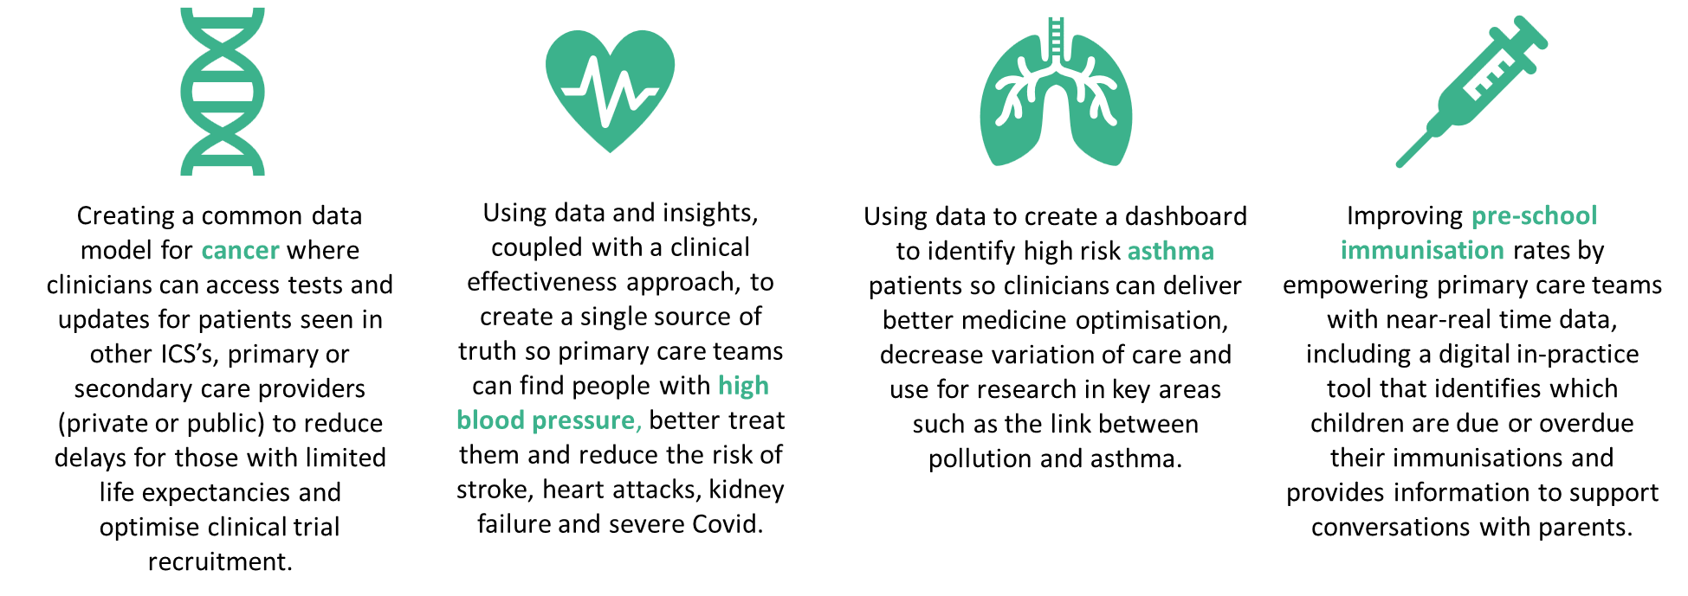

We are now seeking to support a larger number of Data at Scale Improvement Projects that will work across the five Integrated Care Systems in London to:
- Improve health care outcomes
- Improve healthcare planning for individuals and / or populations
- Facilitate academic research
- Support healthcare product research and development
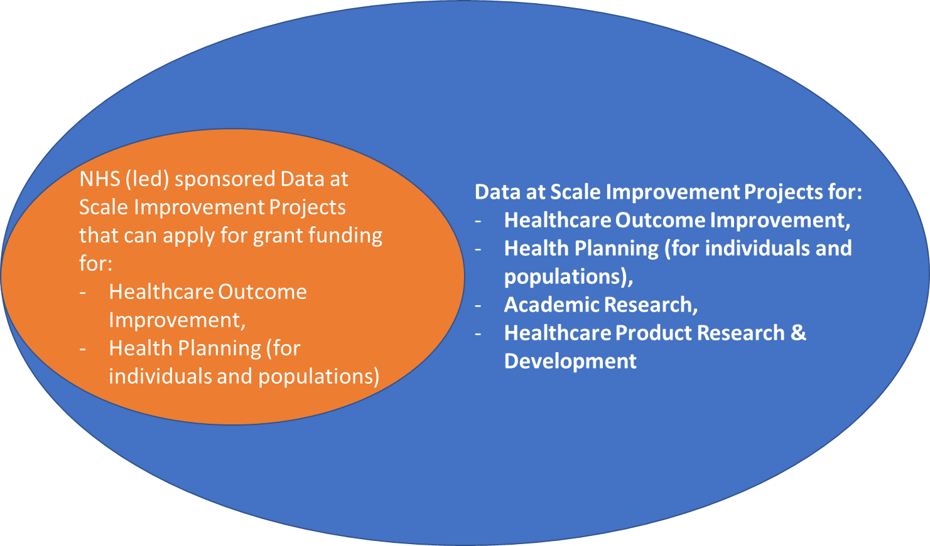
Ongoing public involvement in the programme is at the heart of our work and this included a series of public deliberation events completed in 2022. Following these events it was agreed that projects that are led or sponsored from outside of the NHS will be expected to cover the costs to the health service of responding to data queries and data set access applications. As such each of these non-NHS applications will need to commit to providing £50,000 of funding to each of the five ICSs. The ICS teams reserve the right to increase this amount should the costs of serving the project’s request prove onerous beyond that level of resource provision as the project progresses.

A. Purpose of Funding Call

Primary aim
- To support health improvement that use data at scale across London.
Secondary aims
- Support projects which benefit patients and the public and provide an opportunity for patients and the public to inform these partnerships between the NHS and researchers.
- Utilise and improve the data infrastructure and capabilities that exist in London.
- Use existing secure analytical environments to generate new insight into high priority health issues.
- Enhance the data assets available across London by introducing new datasets, linkages, improvements or tools, and making these accessible to use for health improvement.

B. Priorities and examples for this call
Applications must be for projects that seek to utilise multiple linked datasets to conduct analyses and derive insight for health care improvement. Projects analysing single datasets and/or data relevant to single Institutions are not eligible for the call.
Example areas could include identified performance improvement opportunities that would deliver benefit across London either “Today” (immediate issues and pathway design changes) or “Tomorrow” (longer term condition management, prevention or population health planning).
The available clinical workforce represents the greatest constraint on the NHS and on recovering access standards within the context of the tightening financial resources. Therefore there is a clear opportunity for these Data at Scale Improvement Projects to contribute to ICSs tackling hard to resolve clinical and operational productivity challenges, as well as improving clinical outcomes and patient experience. For example, this could encompass primary care utilisation or waiting list dynamics root cause analysis and patient risk management / prioritisation.
It is anticipated that the Programme may approve up to four projects around academic clinical research. These projects are expected to be funded through academic institutions gaining external grant funding awards and the costs to ICSs to facilitate these projects will be fully recovered through the institution’s grant funding.
Furthermore, it is hoped that there will be up to two projects in healthcare product research and design. Including working with the programme’s partners at MedCity these projects could include commercial partnerships where the ICSs’ facilitation costs will be fully recovered from the commercial partner. In addition a future value transfer arrangement will be agreed (for example free or discounted access to the eventual product, or an equity stake) based on research undertaken for the programme by Imperial College Health Partners.
A range of potential Data at Scale Improvement Projects were surfaced by organisations during the first phase of the Programme although these are not exhaustive:

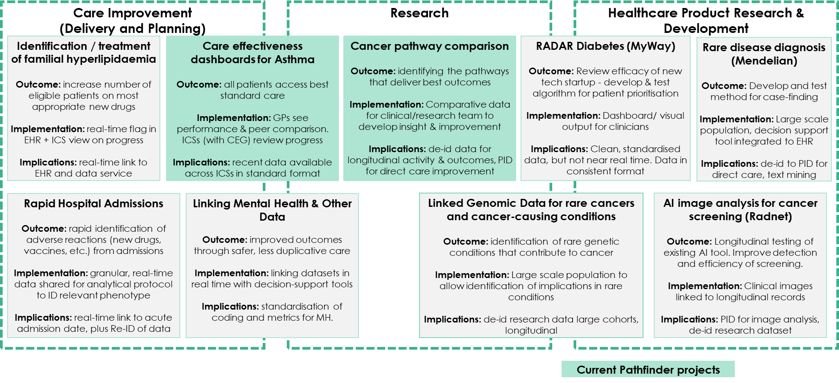
NB – NHS led or sponsored projects that are seeking grant funding from the programme must focus on ICS priorities relating to long term condition identification, prevention and / or management for individuals and / or populations.

C. Independent Information Access Group and Public and Patient Involvement and Engagement (PPIE)
The OneLondon partnership has demonstrated that effective PPIE is critical to successful use of data for the public good. The London Health Data Strategy built on this by undertaking a series of Public Deliberation workshops in early 2022 to determine the London level characteristics of the control framework for accessing health data for improvement. A key recommendation was the establishment of an Independent Information Access Group.
The call requires proposals to demonstrate that PPIE is an integral part of the proposed work.
Applicants are to specify in their application (a) how the proposal has been developed with patients and members of the public, or informed by patient and public views, and (b) how PPIE will influence the work for the funded period.
The application questions have been commented on by citizen representatives within the programme.
All applications to participate in the programme will be subject to review by the Independent Information Access Group which will consist of clinical and citizen representatives.

D. Funding Available
The programme will grant fund NHS led or sponsored projects up to a maximum of four projects and £250,000 for any individual project. This funding will be made available to NHS organisations for the financial year 2023/24 and as such these projects are expected to commence in April 2023 and be concluded by March 2024.
This funding is available for resources associated with analysing the data made discoverable and accessible, supporting associated clinical effectiveness, project management and / or direct PPIE, as well as dissemination, communication and engagement activity and study management.

E. Eligibility
There must be a named lead applicant who will be responsible and accountable for delivery of the project.
Lead applicants may only submit one application to this initiative as a principal investigator, but may be involved in more applications, if listed as a co-investigator.
The application must work with data from all five NHS London ICSs.
Lead applicants are encouraged to consider forming new partnerships with other applicants or partners, where appropriate across London, for example, to grow the footprint or impact of the project or to ensure appropriate data engineering and analysis skills are available as required.

F. Selection Criteria
Projects will be selected based on their ability to:
- Produce high quality results with the ability to demonstrate London-wide health benefits within two years.
- Produce results which are relevant, actionable and impactful with regards to the health needs of the population of London.
- Demonstrate collaboration across organisations.
- Have an identified accountable and credible leader.
- Clearly articulate the impact and NHS benefit in terms of health of the population, public health, hospital or between primary and secondary care.
- Be feasible through use of existing data to deliver health improvements and not be “technology or platform projects.”
- Clearly articulate the projects source of funding and commitment to meeting the costs to the NHS of servicing the project’s data requests.
- Add value to existing London initiatives.
- Demonstrate that patient and public involvement and engagement is an integral part of the proposed work.

Project leads will be accountable for delivery and under regular review by the Programme Delivery Board.

For each NHS Grant Funding application that is recommended as acceptable by the Independent Information Access Group, the selection / prioritisation process will be run by the Programme Delivery Board which includes representatives of the NHS and universities in London together with HDR UK and NHS England’s Transformation Directorate.
Given the finite capacity of the NHS to support such Data at Scale Improvement Projects, the same prioritisation process may be undertaken in the event of over demand from non-NHS led / sponsored projects centred on clinical academic research and / or healthcare product research and development.
Applicants are requested to provide a two-part response:
- A ten section proposal through using the template available by emailing james.friend@nhs.net
- Accompanying material set out in the template, including Gantt Chart and Risk Register
In the event that applications are deemed to cover areas of critical importance to the NHS within London, but to be underdeveloped in one of the specific application sections, a period of support may be made available to the project team to develop their proposal. It is envisaged that this support could be provided by one or more of the existing Pathfinder Projects based on their experience, one or London’s Academic Health Science Networks or by specialists in Data at Scale Improvement work from within the higher education and research community in London.

G. Timing
- Call launched – 12 October 2022
- Webinar for applicants on data availability and access – 14:00 3rd November 2022
- Clarification questions from potential applicants submitted by – 17:00 9th November 2022

It is recognised that not all projects are likely to be in a position to apply for initial review by the Independent Information Access Group (IIAG) on a given date. As such, starting from November 2022, the IIAG will meet every two months to review applications in batches. Applications that are seeking NHS Grant Funding for 2023/24 through this programme are expected to be submitted by 30th November 2022 for review by the IIAG in January 2023.

H: Developing Your Application

The applicant webinar answered many frequently asked questions. You can view it here.

To ensure that your project can commence promptly on receiving approval, applicants are strongly encouraged to consider the below before submitting their application:
- Which datasets could you use?
- Which existing data platform or TRE would you access data from?
- What Data Access Requests will you submit?
- What accreditation will you need?

I: Programme Governance

The London Health Data Strategy Programme is led and governed by NHS England - London Region) supported by OneLondon. All decisions on resource allocation, project support and monitoring will be made by the Programme Delivery Board. Health Data Research UK is supporting the Programme by providing strategic advice and expertise.

https://www.england.nhs.uk/london/wp-content/uploads/sites/8/2019/10/London-Vision-2019-FULL-VERSION-1.pdf

